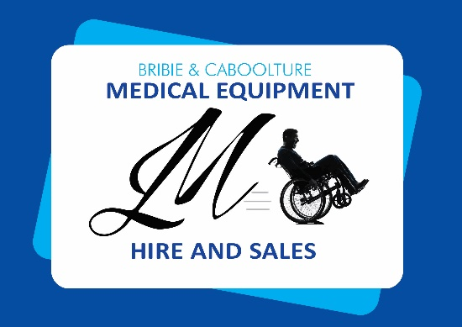
Katie Low Back
Chair
SKU: RG635SG (Sage Green)
RG635BL (Blue)
RG635 GR (Grey)

Features Include :

- Chair mobility wheels on rear legs as standard

- The Backrest of the chair can be folded down for transit + storage

- Strong lightweight construction

- Epoxy powder coated framework

- Vinyl covered upholstery (various colours)Adjustable seat depth

- Contoured padded backrest

- Comfortable padded seat

- Large padded armrests
$395

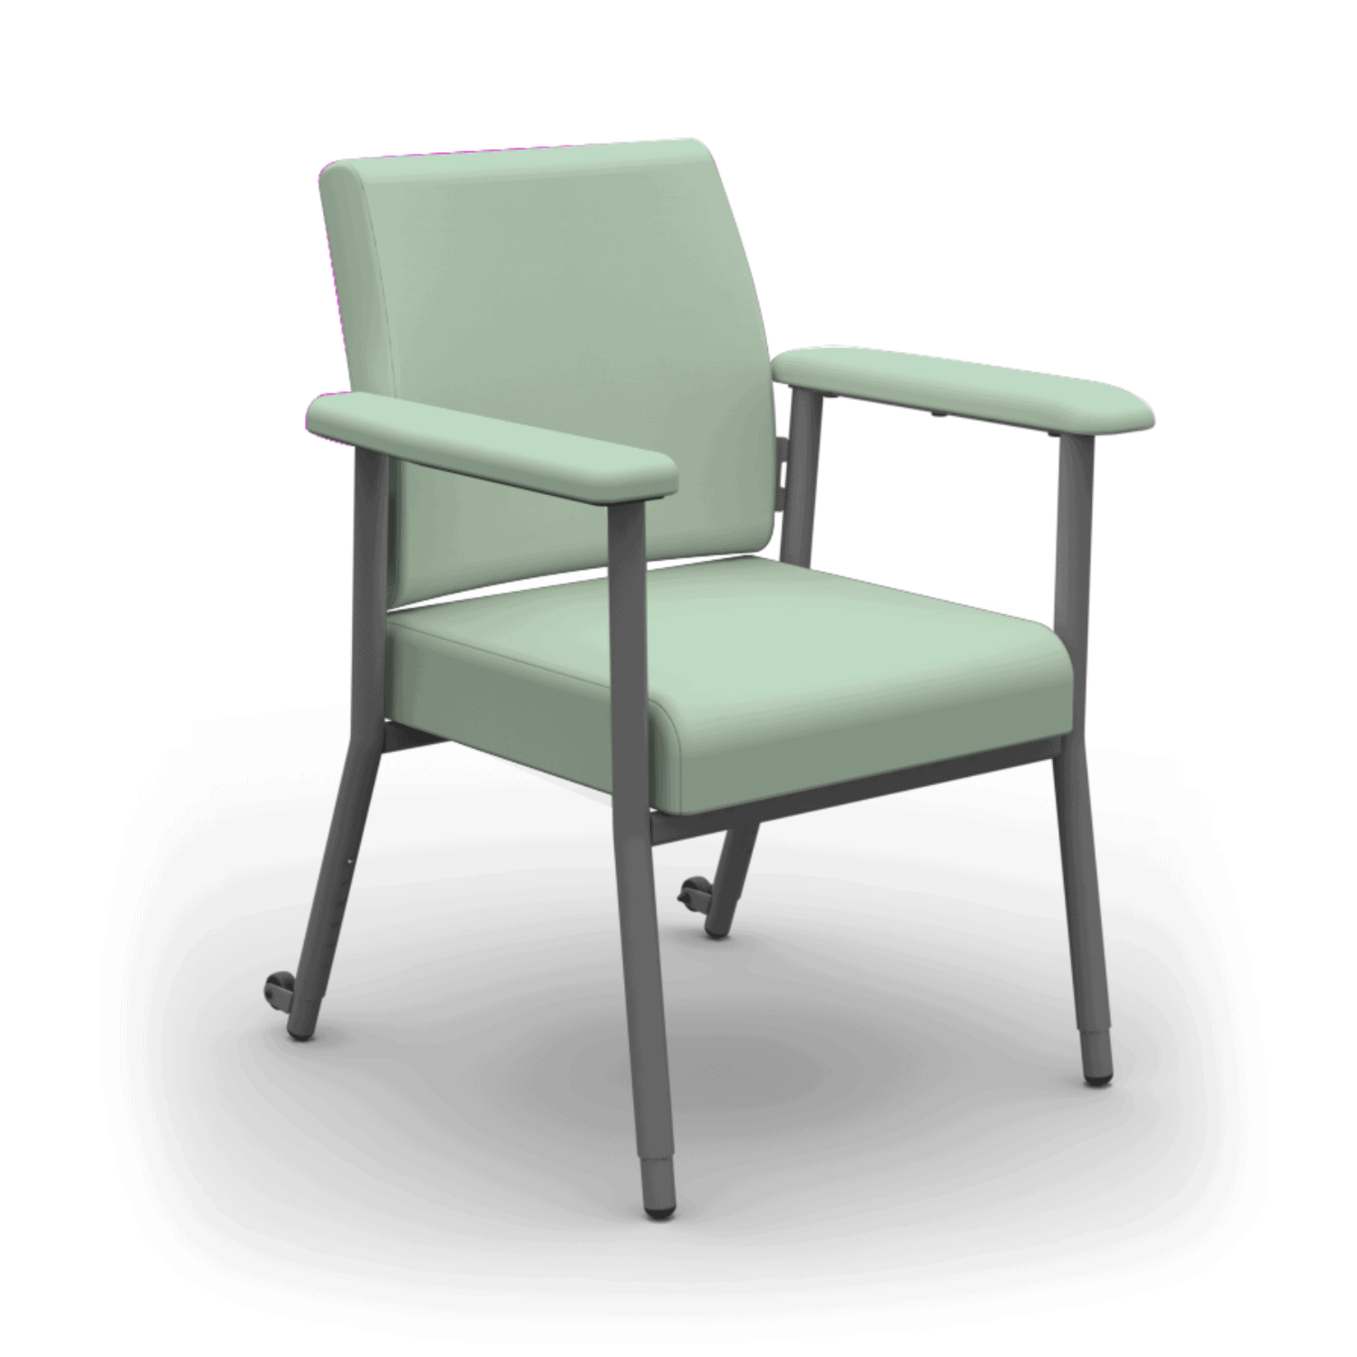
Overall  Height | Overall Width | Overall  Length | Seat Depth | Seat Width | Seat Height | Backrest Height | SWL | Product Weight
915mm | 665mm | 650mm | 435mm – 475mm | 480mm | 450mm – 575mm | 480mm | 200kg | 11kg

