
U-Step II Walking

Stabilizer

FEATURES & BENEFITS
- Users can set their preferred wheel rolling speed
- Casters glide over uneven terrain
- Smaller turn radius for easier maneuvering
- U-shaped base for greater stability, better posture
- Reverse braking: release brakes to stop
- Easily folds for transport
- Lightweight and portable

Sound & Laser cue module attachment - $665
$1325

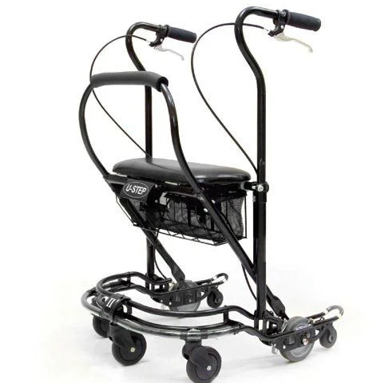
Specifications
Code | US-PC2-S | Safe Working Load | 170kg
Folded dimensions | 107cm x 58cm x 25cm | Unit Weight  (with seat & basket) | 10kg
Total Length | 63.5cm | Patient Height Range | 150cm x 187cm
Total Width | 58cm | Turning Circle | 74cm
Seat Height | 56cm | Seat Width | 51cm

